EMAIL SET-UP
**Required. Incomplete forms will be returned. Please submit to cansupport@aclu.org.

If you have not already, please schedule the email on the CAN Calendar.

Affiliate Name ** | ACLU of New Jersey

Target Audience **
☒ Affiliate Full List
☐ Segmented list (Please provide zip codes, chapter code or any other geo-information below. Please separate zip codes with a comma.)

Testers and Reviewers **
Please provide the email address of those that should receive a test version of this email. One person from your affiliate should respond to the CAN team with edits from all members of your affiliate team. Please don’t have everyone reply directly to the CAN team.
Kpotluri@aclu-nj.org, apeltzman@aclu-nj.org

Email Template **
Note: Images are required for the Action, Event and Banner format emails.

☐ Letter format  (no image) | ☐ Action format  (image 190x230) | ☐ Event Template  (image 350x300) | ☒ Banner Format  (Image 600x300)
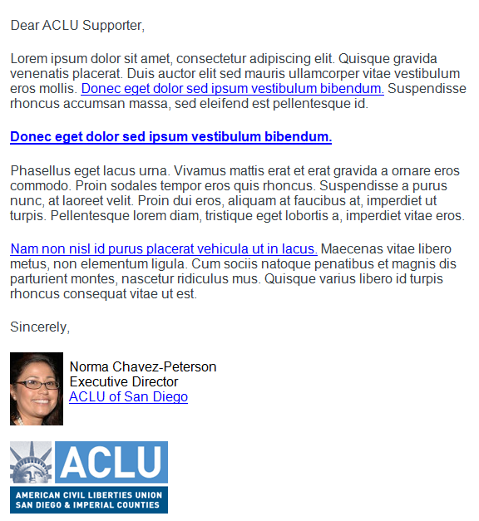 | 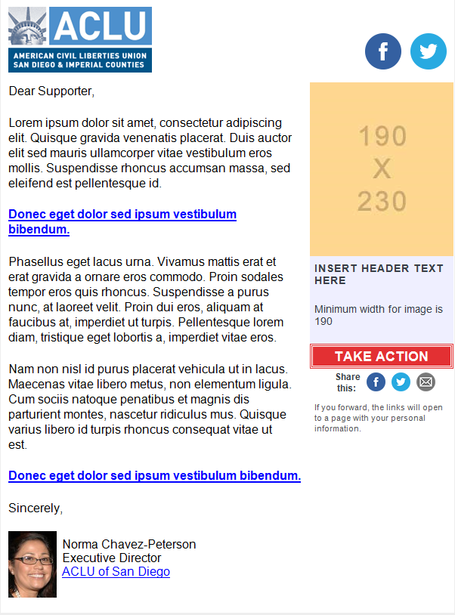 | 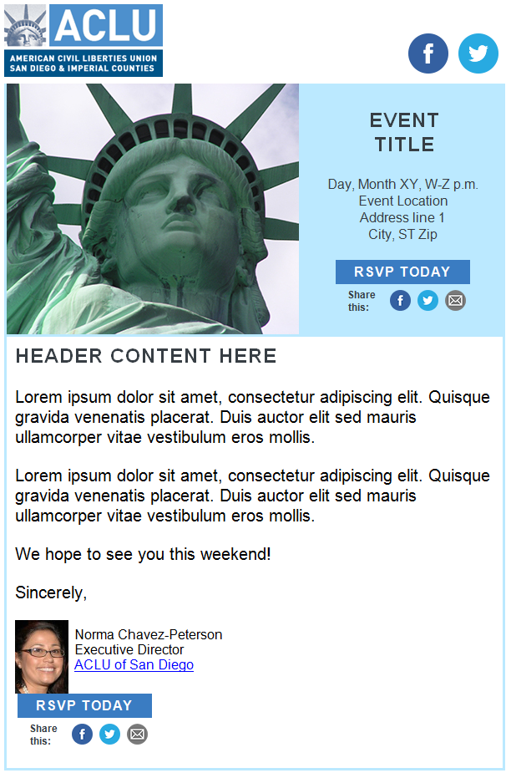 | 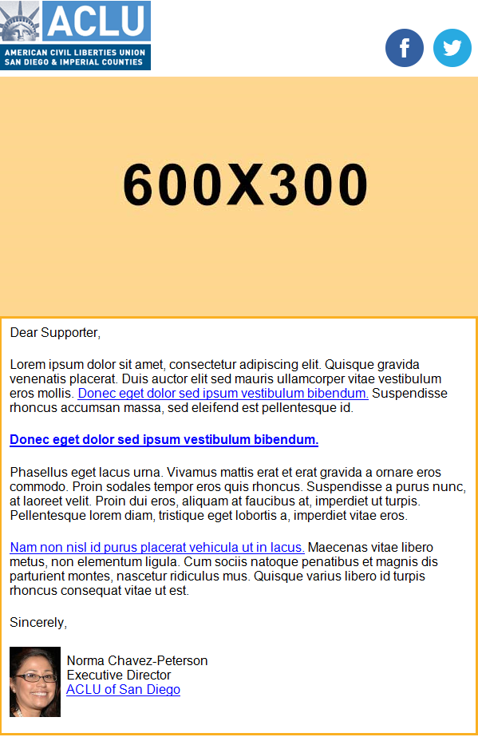

Subject line **
Tease, tell or take action. Avoid initial caps, keep it under 50 characters, and make it compelling for constituents to open your email. Avoid the words “Help,” “Act,” “Marriage,” “Immigration,” “Immigrant,” “Action,” ” Let’s,” and “Save the date.”
School’s back in session – and so are students’ rights

Pre-header Text **
The pre-header is the short summary text that follows the subject line when an email is viewed in the inbox. It is right about the header logo. Include a call to action.
Do the students in your life know their rights for drug testing at school?

Side Box Content (Action & Event format only)
Students: know your rights with police in schools with the ACLU-NJ’s guide. [Download]

Hyperlinks for email message **
https://www.aclu-nj.org/yourrights/fileacomplaint/onlinecomplaint/

www.facebook.com/ACLUNJ
www.twitter.com/ACLUNJ

https://www.aclu-nj.org/download_file/2066

Email Body Content **
Keep the content brief. One of the worst mistakes we make is trying to include the entire story into the email message. Think about when you open an email in your inbox. Do you read every single word in there? Probably not. Find a way to summarize the content compelling way, and let them click through to a page on your website for more information.

Answer the these three questions for the reader when you write your message:

- What are you asking me to do? Always give the reader an action to take. Your call to action should be able to stand-alone. Remember, people scan their emails, and if there is one thing you want your recipient to notice, it is your call-to-action.
- What is in it for me? You know the value of your email content, but does your recipient? Tell them why taking action is important for them or why they should attend an event.
- Why should I care? Write in the second person – orient the copy toward the reader and not the ACLU. Readers take action on things that are about them or affect them.
Dear ACLU-NJ supporter,

Fall is in the air, and school is once again in session. Do the students in your life know their rights for drug testing at school? We’d like to help you learn. And students and parents: if your rights are violated, we want to hear from you. (It’s Banned Books Week, so that goes for censorship, too – this week or any week.)

Earlier this month at a Randolph High School football game, as many as 75 students were forced to take an alcohol test under threat of suspension. Fewer than five students had a positive result. Breathalyzers may become a part of the school district’s substance abuse policy moving forward.

That raises big red flags for us. Some students’ parents think their constitutional rights were violated – and the parents are likely right.

Here’s what all students and parents need to know about drug testing:
- When it’s based on suspicion of drug or alcohol use, schools can only order testing when officials have reasonable, individualized suspicion. They can’t order tests on a hunch or by mere association.
- Schools can have a random drug testing program for students who participate in extracurricular activities (or for students who park on campus) if they’ve demonstrated a special need for it.

If you or someone you know was affected by Randolph High’s alcohol-testing dragnet, please reach out to us. And this school year, if students you know experience civil liberties violations in school, we want to know. Contact our intake line at 973-854-1719 or submit an online complaint. You can also connect with us on Facebook or Twitter, or take a look at our guide on students’ rights with police.

Sincerely,

Amol Sinha
Executive Director

Social Share Buttons **
Social share buttons are added to the Action and Event templates. Please provide the language below for Twitter. We cannot customize the email or Facebook links.

Twitter:
Students: know your rights with police in schools with the ACLU-NJ’s guide. https://www.aclu-nj.org/download_file/2066

